*Green Society Public School*

**Ra.Na.Pa-7, Sauraha Chitwan**

**First Terminal Examination -2082**

**Subject: Art F.M. 25**

**Class: Four**

**Name: Roll.no**.:

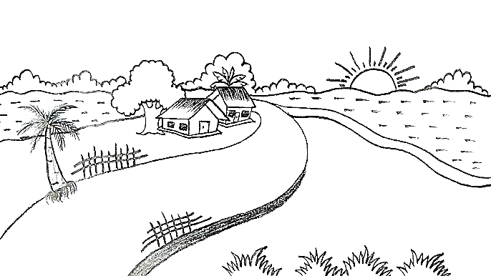**Q.N.1) Colour the picture. [10]**

**Q.N.2) Draw a picture of a rose and do pencil colour.[15]**